AI Powered E Commerce Order Recovery & Customer Retention
Zapier | Shopify | WooCommerce | HubSpot | OpenAI | Stripe | Slack | Gmail | Zendesk | Airtable

Project Overview
Built an automated e commerce workflow that monitors customer orders and identifies opportunities for payment recovery, abandoned cart recovery, delivery issue handling, customer retention, and upselling.

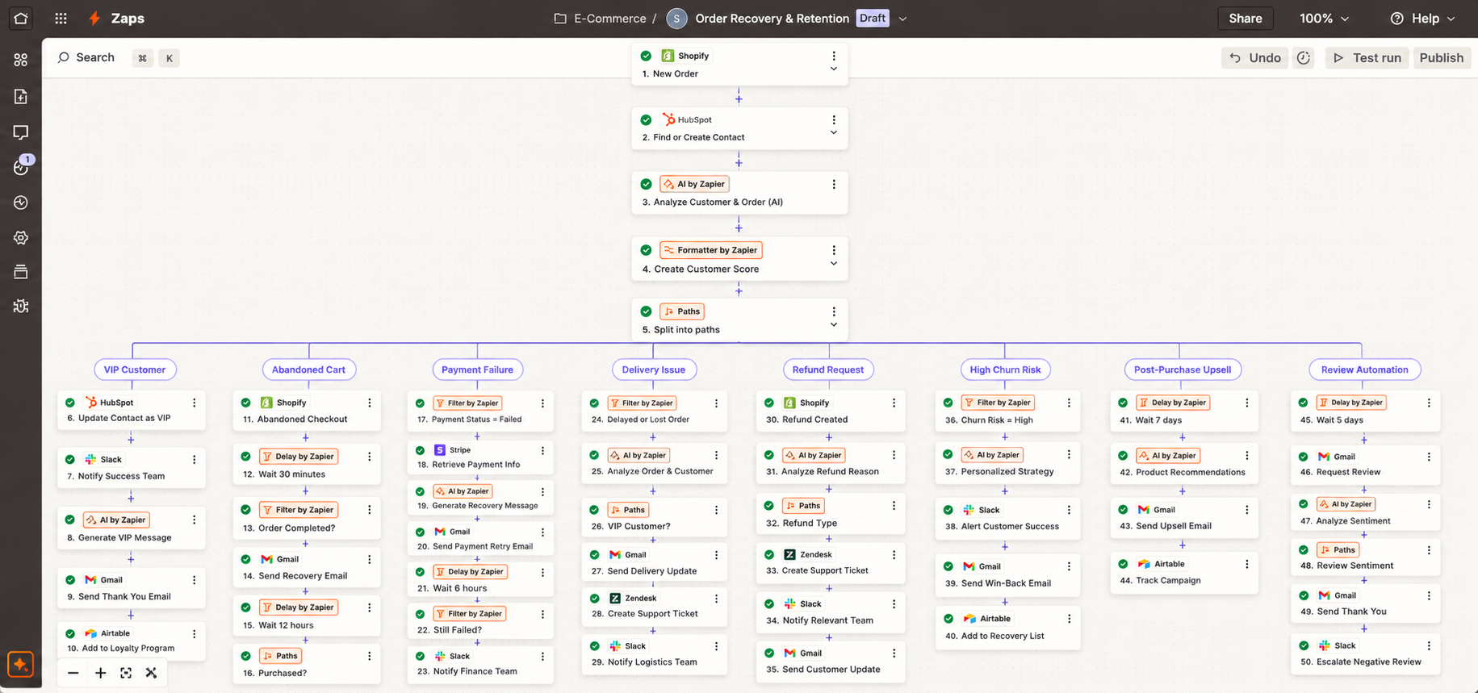

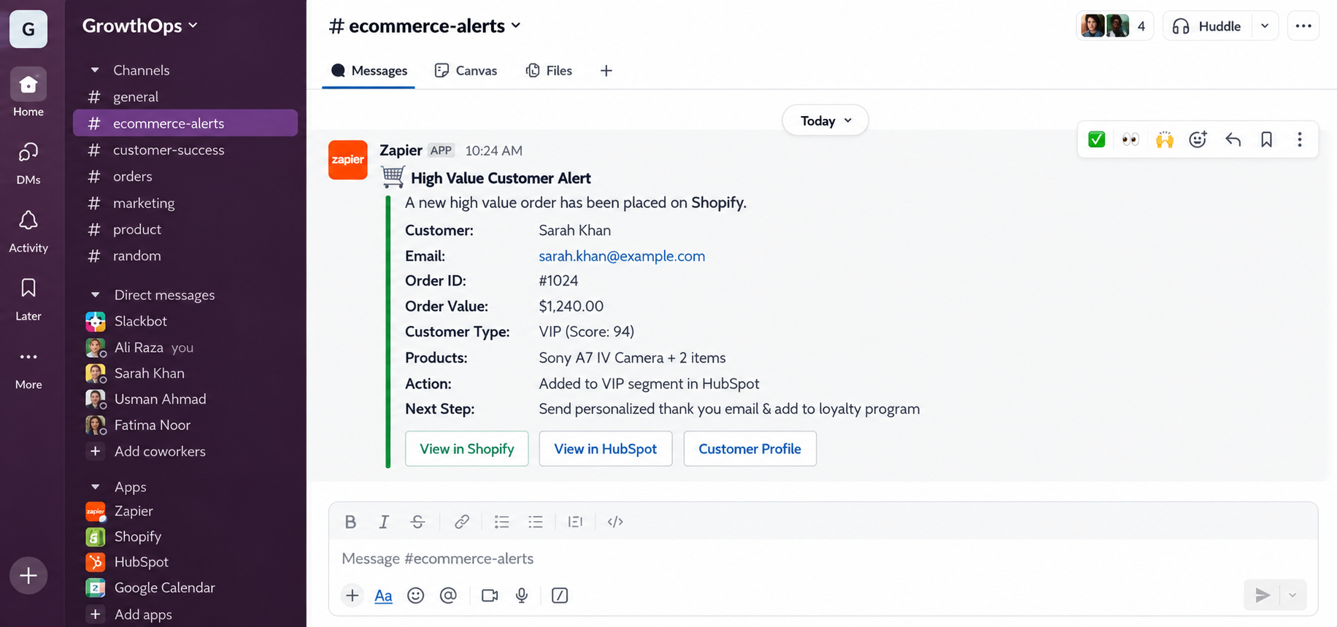

Customer Analysis
The system checks:
• Customer history
• Order value
• Lifetime value
• Purchase frequency
• Average order value
• Refund history
• Recent engagement
• Customer risk
Customers are scored and routed into the appropriate workflow.

VIP Customer Flow
High value customers are automatically:
• Marked as VIP in HubSpot
• Sent to the customer success team through Slack
• Sent personalized thank you messages
• Added to loyalty and cross sell opportunities

Abandoned Cart Recovery
The workflow:
• Detects abandoned checkouts
• Waits 30 minutes
• Checks whether the order was completed
• Sends a recovery email if the purchase was not completed
• Waits and checks again
• Sends additional follow up when required

Payment Recovery
For failed payments:
• Checks the payment status
• Retrieves payment information
• Sends payment recovery emails
• Rechecks the payment
• Alerts the finance team when payment remains unsuccessful

Delivery & Refund Handling
Delivery problems are routed based on customer value and issue type.
The system can:
• Detect delayed or failed deliveries
• Notify customer success for VIP customers
• Send delivery updates
• Create Zendesk tickets
• Analyze refund reasons
• Route billing, shipping, or product issues

Customer Retention
Customer feedback is analyzed to identify:
• Customer sentiment
• Churn risk
• Main complaints
• Customer value
• Recommended recovery action
High value customers with high churn risk are escalated to customer success for personalized recovery.

Upselling & Reviews
After a successful purchase:
• Analyzes purchased products
• Identifies related products
• Sends personalized recommendations
• Requests customer reviews after delivery
• Routes negative feedback into a recovery workflow

Reporting
Important customer and order events are stored in Airtable, including:
• Customer
• Order value
• Customer score
• Issue type
• Recovery action
• Customer status

Technology
• Zapier
• Shopify / WooCommerce
• HubSpot
• OpenAI
• Stripe
• Slack
• Gmail
• Zendesk
• Airtable

Result
A complete e commerce automation system that connects order monitoring, abandoned cart recovery, payment recovery, delivery issues, refunds, customer retention, upselling, and review management into one workflow.

